**Communicating My Analysis on The Mint Classics Databases**

First and foremost, I will like to look at the warehouses on Mint Classics Databases. Now let’s look at the below query and result:

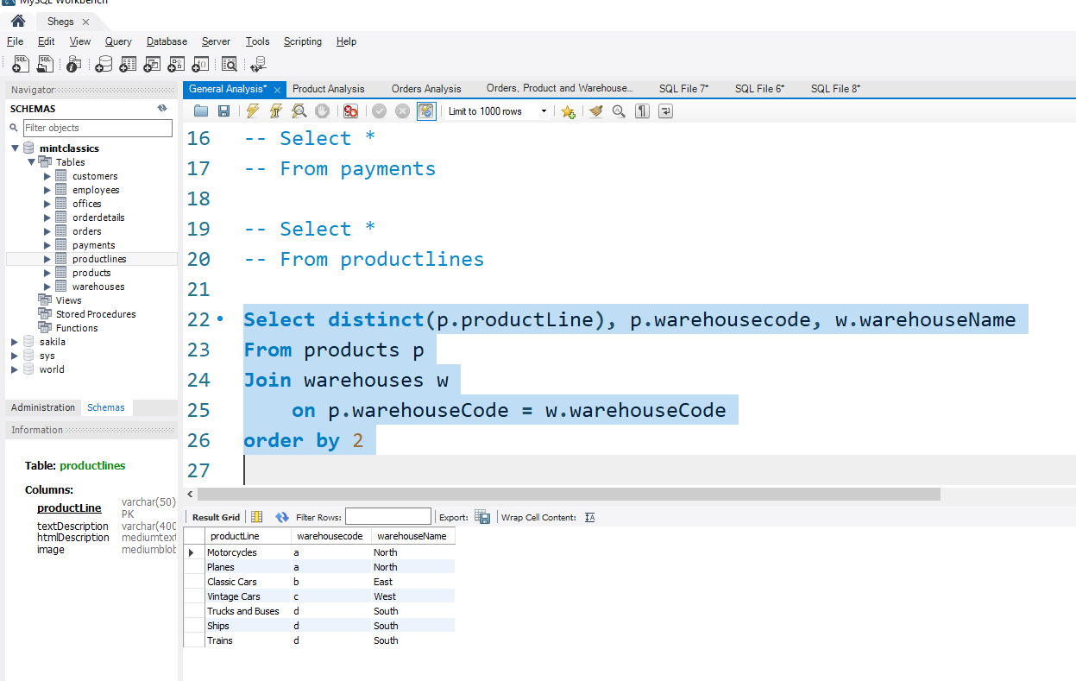

*Fig 1:sql query and result showing the different product line, warehouse code and warehouse name*

From fig 1, we can see that we have four warehouses with warehouse names, North, East, West and South with code as ‘a’, ‘b’, ‘c’ and ‘d’ respectively. Also, warehouse with code ‘a’ have motorcycles and planes as the product line stored in with while that of ‘b’ have Classic cars, that of ‘c’, have vintage cars and finally ‘d’ has Ships, Trains, Trucks and Buses stored in it.

Having, understand the specifics of each warehouse, we now looked at the different quantity of stock (product line) ordered that have been shipped out of these warehouses.

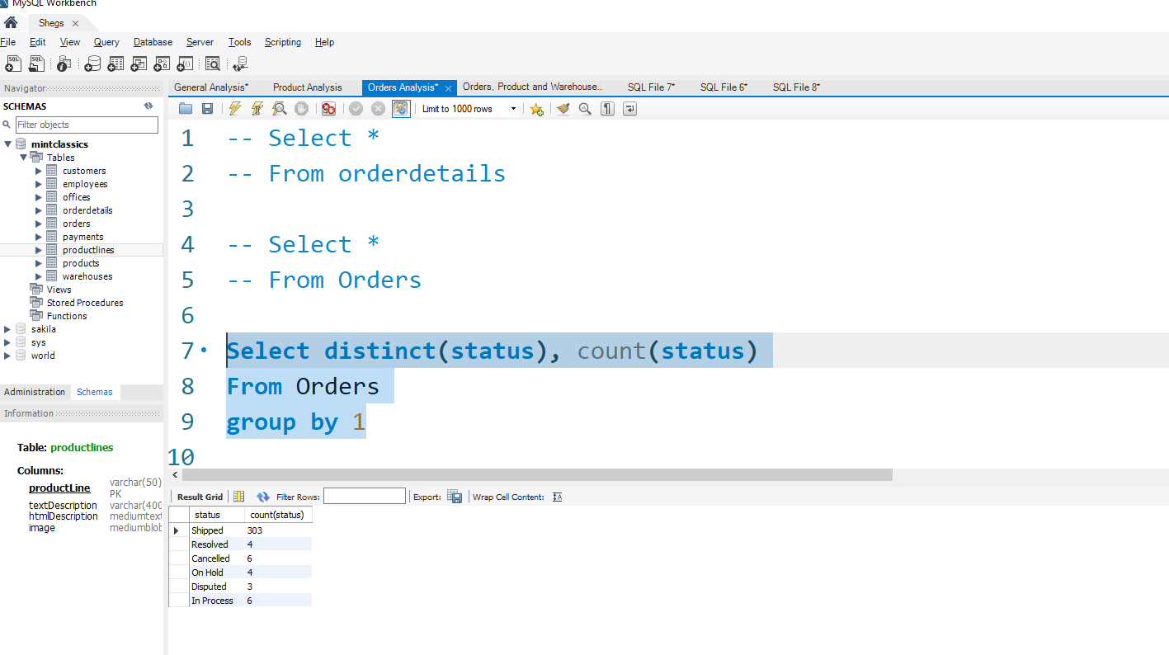

*Fig 2:sql query and result showing the different status on all orders*

Looking at fig2; we can see the different status and their counts of orders made on Mint classic. Our focus will be on those that have been shipped out of the warehouses. The ‘shipped’, ‘resolved’ and ‘disputed’ status are what we will be looking at as this status indicate that stocks have been shipped off the warehouse. Though 2 sets of stocks in the cancelled status were shipped but in view of the reasons, they will be brought back to the warehouse.

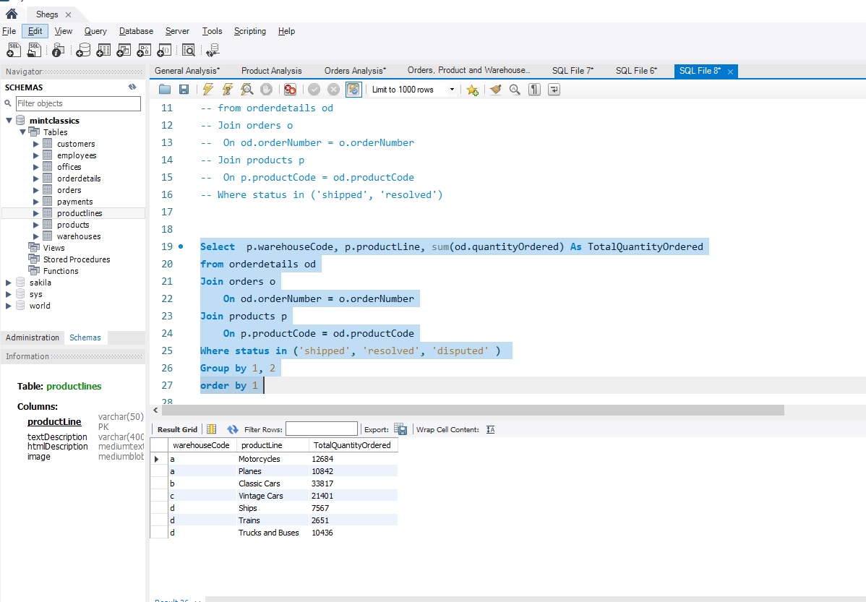*Fig 3: sql query and result on ordered product having status of ‘shipped’, ‘resolved’ and ‘disputed’.*

From fig 3, we can see the total quantity of stock ordered and shipped with it’s different product lines. Now I would love to include the quantity of product ordered it status report ‘in process’ as this product would be shipped out of their warehouses in no distant time.

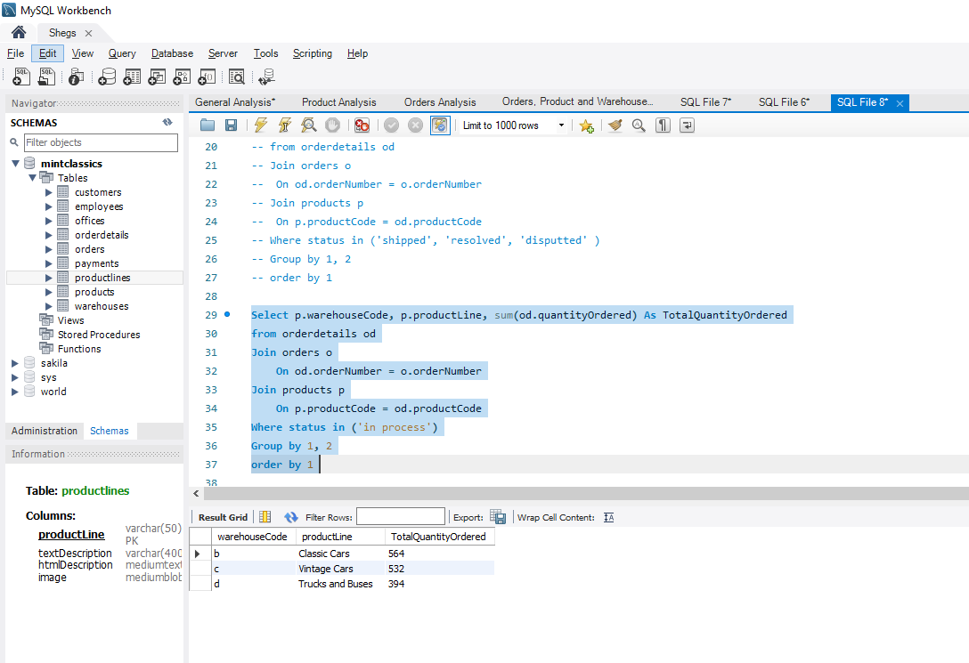

*Fig 4: sql query and result of product ordered with status report ‘in process’.*

We can see from fig 4 that only the product line classic cars, vintage cars and truck and buses are with the status ‘in process’, for this would soon leave its respectively warehouse. So, I want to include them on total quantity of product that have been shipped.

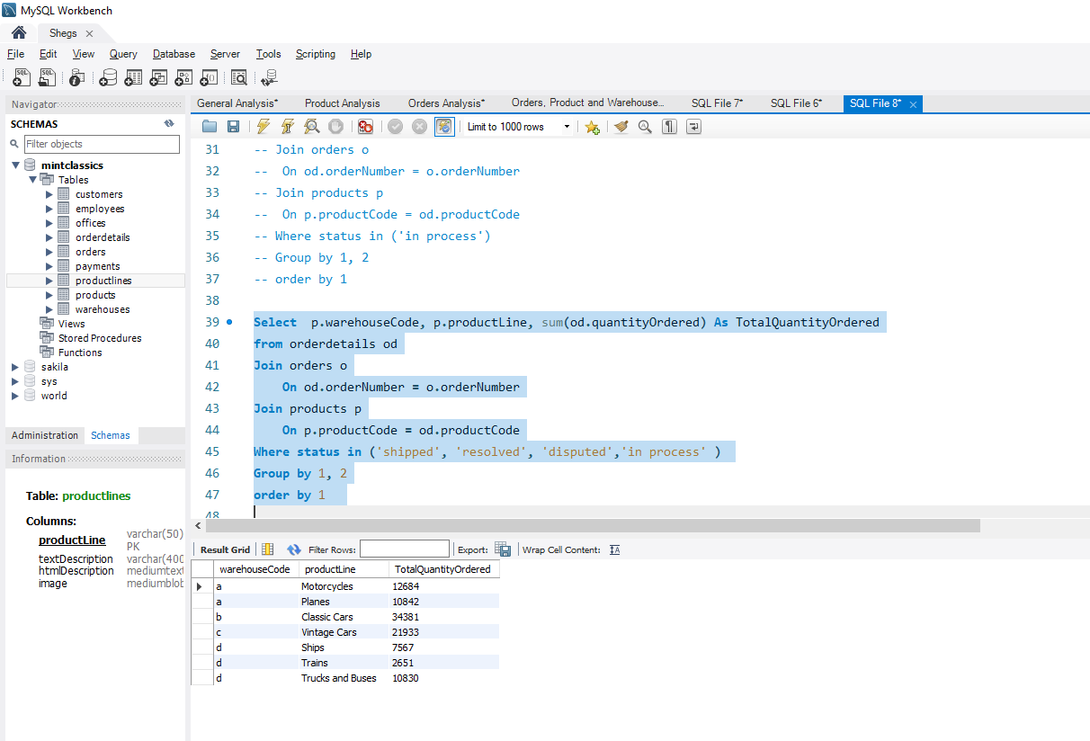

*Fig 5: sql query and result on all ordered products with status ‘shipped’, ‘resolved’, ‘disputed’ and ‘in process’.*

Now we can clearly see the total quantity that have been ordered and shipped and will soon be shipped out of the warehouse as we spoken about earlier.

Let’s pause a bit and see the total quantity in stock initially in the warehouse.

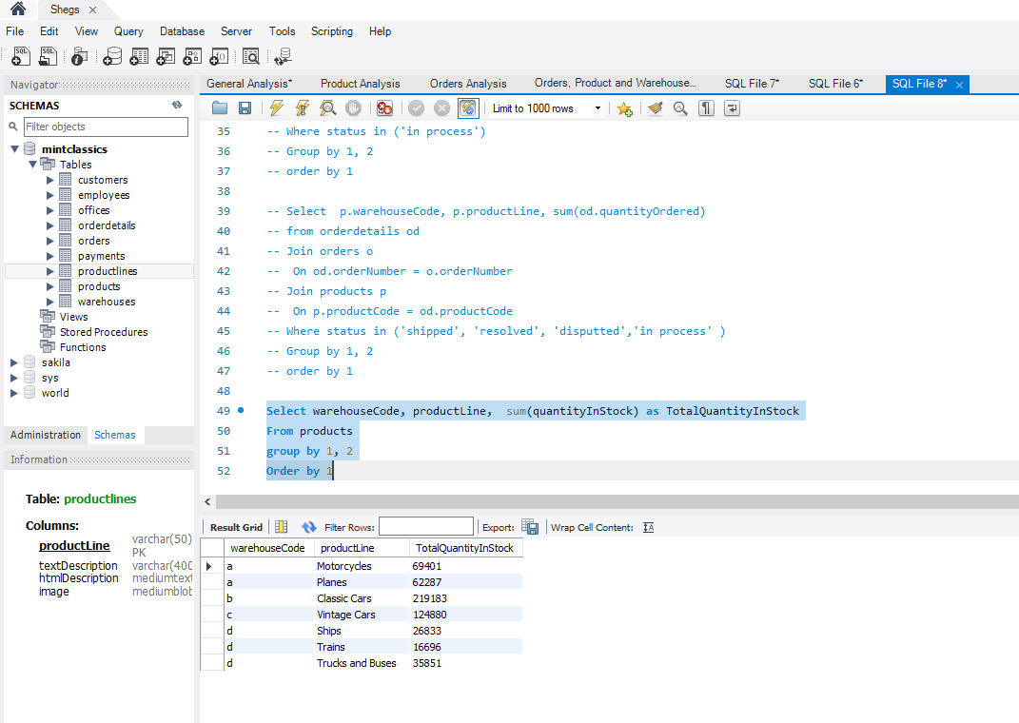

*Fig 6: sql query and result of all product line and their total quantity in stock in their respective warehouses.*

We can analyze fig 5 and fig 6 so as to get the total number of quantities of each product line remaining in each warehouse.

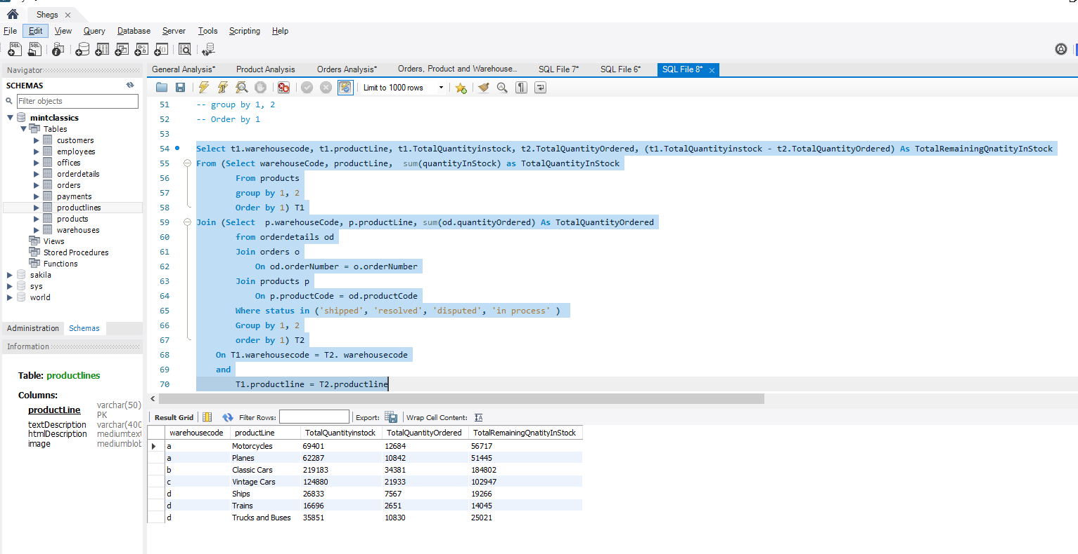

*Fig 7:sql query and result showing the remaining quantity of each product line in each warehouse.*

Now, let’s talk about the fig 7. We can see;

1. Total of **12,684 motorcycles** was shipped out of the warehouse with code ‘a’ leaving **56,717 motorcycles**
2. A total of **10,842 planes** shipped leaving **51,445 planes** remaining in same warehouse as that of the motorcycles.
3. A grand total of **108,162** products remaining in warehouse ‘**a’**
4. A total of **34, 381 classic cars** was shipped out of warehouse ‘b’ and this leaves a total of **184,802 classic cars** remaining in warehouse ‘**b’.**
5. A total of **21, 933 vintage cars** was shipped out of warehouse ‘c’ leaving a total of **102,947 vintage cars** remaining in warehouse **‘c’.**
6. A total of **7,567 ships** was shipped out of warehouse ‘d’ leaving a total of **19,288 ships** remaining
7. A total of **2,651 trains** was shipped out of warehouse ‘d’ leaving a total of **14,045 trains** remaining.
8. A total of **10,830 trucks and buses** was shipped out of the warehouse ‘’d’ leaving a total of **25,021 trucks and buses** remaining.
9. A grand total of **58,354** of products are remaining in warehouse **‘d’**

Projection /Solution

1. In view of the about numbers, we can see that the sum of both the quantities of ships and that of train give rise to **33,333** quantities and this quantity is not up to the total quantity that left the warehouse ‘b’ since only **34,381** classic cars was shipped out. So, we can reorganize warehouse ‘b’ to contain the vintage cars, ships and train as this won’t affect its capacity.
2. Also, we just have a difference of **3,088** quantities as regard the number of trucks and buses left in warehouse ‘d’ and that of the total quantities of vintage cars that left warehouse ‘c’. So, we can combine both the vintage car product line and that of the truck and buses product line in warehouse ‘c’
3. Warehouse a still retains it usual product line which is motorcycles and planes product line

In conclusion we see that we have successful eliminated warehouse ‘d’ as its formal products have been shifted to warehouse ‘b’ and ‘c’. Therefore, we have

**Product line warehouse Code**

* **Motorcycles a**
* **Planes a**
* **Classic cars b**
* **Ships b**
* **Trains b**
* **Vintage Cars c**
* **Trucks and Buses c**